TECHNICAL SPECIFICATION

Equipment for dynamic mechanical analysis

- Delivery description
The subject of the contract is delivery of the testing equipment for dynamic mechanical analysis (DMA). The delivery must include device for materials testing with all necessary accessories mentioned below. The delivery must include also the suitable PC software for equipment operation and analysis of measurement data Necessary part of the delivery is transportation to place of usage and all actions needed for assembly and commissioning of the equipment. Transport and the actions must be taken into the bid price.
- Basic technical description of the subject of delivery
Dynamic mechanical analysis represents technique for determination of material visco-elastic behaviour during different temperatures and frequency (sinusoidal load is applied on the specimen), mainly of polymers, such as Young modulus, internal friction, stiffness, shear modulus and others. Dynamic mechanical analysis is the technique which allows to achieve information about studied polymers and some composite materials that can not be obtained by standard mechanical testing like in case of the metals and/or ceramics.
  - Detail description

- Temperature range at least within -170 to 600 °C
- Load frequency up to 100 Hz
- Minimum range of forces applicable to the specimen 0,001 N to 10 N
- Including basic holder for measurement
- PC software for machine operating, data collection and analysis
- Ability to determin CTE of samples (TMA analysis)
- Example of possible solution
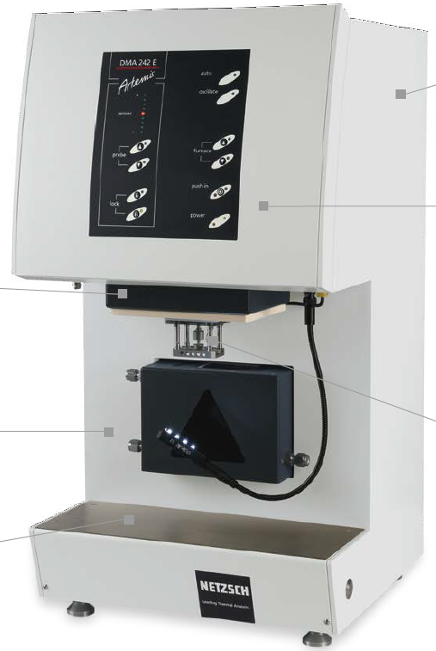

- Place and scope of delivery
Packaging and transportation costs must be a part of the delivery and taken into the bid price. Installation and commissioning of the DMA equipment at the address below must be a part of the delivery and taken into the bid price too.
Address of the place of performance:
Continental Automotive Czech Republic, s. r. o.
Na Rovince 879
720 00 Ostrava – Hrabová
- Requested documents

- CE declaration of conformity
- User´s manual
- List of spare parts
- Hazard notes for application

- Operators and maintanance training
Operations and maintenance training must be an integral part of delivery and taken into the bid price. Range of the training must be at least sixteen hours, two working days. Offered range of the training will be stated in the bidder´s offer.

