**TECHNICAL SPECIFICATION**

**Testing equipment for differential scanning calorimetry**

1. **Delivery description**

The subject of the contract is delivery of the testing equipment for DSC (differential scanning calorimetry). The delivery must include device for materials testing with all necessary accessories mentioned below. The delivery must include also the suitable PC software for equipment operation and analysis of measurement data. Necessary part of the delivery is (and into the bid price must be included) transportation to place of usage and all actions needed for assembly and commissioning of the equipment.

1. **Elementary technical description of the object of delivery**

Differential scanning calorimetry represents experimental technique for determination of amorphous materials‘ and/or partly amorphous materials‘ (polymers, glasses, composite materials) and metals‘ (with low melting points) physical properties, such as melting and crystallization temperature, glass transition, specific heat capacity, phase diagrams oxidative stability and many others. DSC is the technique which allows to achieve informations about studied materials, that could be hardly achieved by any other technique in so complex form. DSC is a technique in which the difference between the heat flow rate into a sample pan and that into a reference pan is determined as a function of temperature and/or time. During such measurement, the sample and reference are subjected to the same controlled temperature program and a specified atmosphere.

The contracting authority requires a possibility to extend the equipment about measurement temperature range by usage of liquid nitrogen in the future. The equipment necessary for achieving of very low temperatures by using of liquid nitrogen must not be a part of delivery and is not included into the bid price, required is only a possibility of extension for future needs of the contracting authority.

* 1. **Detail description**

1. Possibility to cover a minimal temperature range from -150 to 700 °C when using liquid nitrogen
2. Minimal temperature range without liquid nitrogen from -90 to 700 °C
3. Possibility to exchange cooling and sensor units
4. DSC sensor resolution ≤ 0,06 µW
5. DSC heating chamber temperature resolution ≤ 0,009 °C
6. Ability to work with UV curing extension
7. PC with a software for DSC machine operating, data collection and analysis
8. The delivery should include stamp for specimen preparation and at least 200 aluminium specimen cups with covers
9. Possibility to use gas atmospheres: inert, oxidative, static and dynamic
10. Modulated DSC technique application
11. Autosamples extension must be possible
12. Possibility to export data to MS Excel format
13. **Example of possible solution**

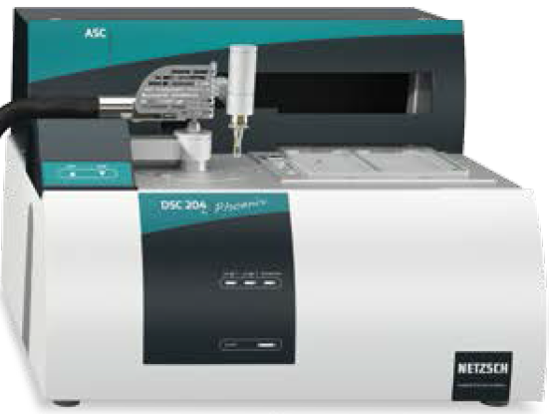

1. **Place and scope of delivery**

Packaging and transpostation costs have to be a part of the delivery and taken into the bid price. Installation and commissioning of the DSC equipment at the address below must be a part of the delivery and taken into bid price too.

Address of the place of performance:

Continental Automotive Czech Republic, s. r. o.

Na Rovince 879

720 00 Ostrava – Hrabová

1. **Requested documents**
2. CE declaration of conformity
3. User´s manual
4. List of spare parts
5. Hazard notes for application
6. **Operators and maintanance training**

Operations and maintenance training (at least sixteen hours, two working days) must be an integral part of delivery and taken into the bid price. Offered range of the training will be stated in the bidder´s offer.