TECHNICAL SPECIFICATION

Pull shear testing

- Delivery description
The subject of the contract is delivery of the pull shear testing equipment. Delivery of the pull shear testing equipment must include mechanical testing frame with all necessary accessories mentioned below. Testing machine must be equipped by temperature chamber and proper PC software for measurement data evaluation. Necessary part of the delivery is transportation to place of usage including unloading of the delivery and all actions needed for installation, commissioning, testing of functionality and operator training.

- Elementary technical description of the object of delivery
Pull shear testing equipment is a device that is used for mechanical testing (tensile, compression, shear and pull testing at room, elevated and/or low temperatures). Such testing procedures are necessary for determination and verification of material´s mechanical properties. This testing equipment must be suitable for all compact specimen including metals, ceramics, polymers and composites.
  - Detail description

- Max. pulling force >= 5 kN
- Max. compression force >= 5 kN
- Force resolution 0,02 N or better (more sensitive resolution), for applied force >=5 kN
- Tensile jaws for the universal testing machine which allows tensile testing according to the ISO 527-1 must be part of the delivery (to be able to test specimen prepared according to the ISO 3167 type 1A). Tensile jaws or their combination must at least cover a working (measuring) range from -40 to 150 °C
- Pressure plates for the universal testing machine which allows compression testing according to the ASTM D695 and ISO 604. Pressure plates must allow compression testing of the specimen that can be either blocks and cylinders. Pressure plates or their combination must at least cover a working (measuring) range from -40 to 150 °C
- Measurement accuracy (according to the DIN EN ISO 7500-1) ± 1 % and/or better
- Traveling distance of measuring head >= 1000 mm
- Machine stiffness >= 10 kN/mm
- Temperature chamber for tensile testing with minimal temperature range -50 to 250 °C
- Temperature resolution <= 1 °C
- PC software for data collection and graphical analysis

- Illustrative example of possible solution
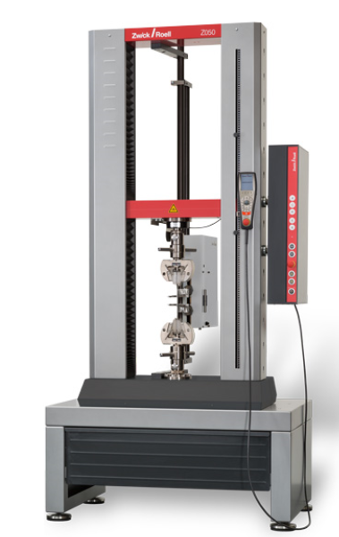

- Place and scope of delivery
Packaging, delivery and unloading costs have to be a part of the offer and contained in the bid price. Installation of the pull shear testing equipment in the laboratory in Ostrava, commissioning, testing of functionality of the equipment and operator training according point 6 of this document must be a part of the offer too and contained in the bid price.
Address of the place of performance:
Continental Automotive Czech Republic, s. r. o.
Na Rovince 879
720 00 Ostrava – Hrabová

- Requested documents

- CE declaration of conformity
- User´s manual
- List of spare parts
- Hazard notes for application

- Operators and maintanance training
Operations and maintenance training (at least eight hours) must be an integral part of the offer and contained in the bid price. The training will take place in the range of at least 8 hours. The bidder shall include the offered range of the training into the offer.

